**California State University Sacramento**

**Electrical and Computer Science Department**

**EEE 193A/CPE 190 - Product Design Project I**

**Final Project Report**

**CNC Laser Cutter and Engraver**



**Team Member:** Ammar Ahmed/Thomas Bock/Tan Hua/ Michael Golez

**INSTRUCTOR:** Suresh Vadhva

***Abstract***

**Contents**

**I.** **Design Overview**

**A.** **Introduction**

**B.** **Equipment List**

**C.** **Team Member Summary**

**D.** **Detailed Description**

a. Mechanics

b. Laser System

c. Software

d. Computer Vision

**II.** **Proposals**

**A.** **Funding Proposal**

**B.** **Product Proposal**

**III.** **Work Breakdown Structure (WBS)**

**A.** **Outline of WBS**

Mechanics

Laser System

Software

Computer Vision

**B.** **Project Timeline**

Milestone I

Milestone II

Milestone III

**IV.** **Risk Assessment**

A. Laser

B. Mechanics

**V.** **User Manual**

A. Operation

B. Hardware Requirements

C. Software Requirements

**VI.** **Design Documentation**

**VII.** **Breakdown of Hardware Subsystems**

A. Camera

B. Laser Diode

C. Arduino

D. Block diagram

**VIII.** **Breakdown of Software Subsystems**

A. Object Detection Algorithm

B. Generating of G-Code

C. Laser control

D. Flow Chart

**IX.** **Mechanical Drawings and Documentation**

**X.** **Test Plan for Hardware**

**XI.** **Test Plan for Software**

**XII.** **Integration Plans**

**XIII.** **Accomplishment**

**XIV.** **Conclusion**

**XV.** **Appendix A: References**

**XVI.** **Appendix B: Code**

# Design Overview

## **Introduction**

All around the world there are different tools that are used to create or modify an object in order for certain materials to be applicable and used by humans everywhere. Types of device that is used by industry and commercialize companies include a laser cutter/engraving machine. Some applicable uses that laser machines have displayed over the years include Architectural models, fablabs and educational settings, and displays and gadgets. By possessing a laser machine and instrumenting a localized floorplan of its construction a user, can efficiently create objects of interest that can provide necessity or

The machine operates through the use of a high-energy infra-red laser light beam. By implementing a focusing lens towards the laser diode, the light beam is concentrated into a single focal point. The focal point allows maximum melting and vaporization of the desired material of interest. In order to alter the position of the laser into a desired location, a computer program known as CNC drives the positon of both the x and y axes. Asides the orientation of the axes, CNC codes can adjust the intensity of the laser to enhance the engraving or cutting of the material. Finally, by using machine vision, we can determine the position of the object relatively to the workspace through the process of object orientation. This process allows finer cutting and engraving for better result. The construction and programming of the CNC Laser Machine will be conducted into four different parts: the mechanics will handle the positions of the CORE X-Y axes, the Laser Diode will generate the light beam for the cutting and engraving, the CNC software will allow for control and intensity of the overall system, and finally detection system will detect the workspace for maximum efficiency.

## **Equipment List**

1. Mechanical Parts:
   1. Stepper Motor (2x):
   2. Belts(2x)
   3. Linear Rods(4x)
   4. Linear Bearings(6x)
   5. LED strip(1x)
   6. Aluminum Extrusions(7x)
   7. 3D Printed Parts:
      1. X-Y Carriages()
      2. Toolhead()
      3. Linear Rail Mounts()
2. Laser System:
   1. Laser Diode: 2W 445nm M140 Blue Diode in Copper Module W/Leads
   2. Laser Lenses:405-G-2 Glass Lens for Aixiz Laser Module 405nm 445nm
   3. Laser Driver:
3. 1.8 X-Drive V6 Laser Driver-M140-PLTB450-PLTB450B-NDG700-NDG7475
4. 12V TTL 200mW to 3W 445nm 450nm Laser Diode LD Power Supply Driver
5. 2.5 Amp Adjustable Safety Compliant Laser Diode Driver Kit, for UV-Blue diodes, with International Power Adapter
6. Computer Vision:
   1. Web Cam (x1): Logitech C270 720p 3-MP
7. Microcontroller:
8. Arduino Mega with a RAMPS 1.4 motor shield
9. ACE 2510S 5V Cooler Brushless DC Fan 25*10mm Mini Cooling Radiator(2x)
10. Meanwell Style Power Supply(12V 30A)
11. Arduino Shield:

## Team Member Summary

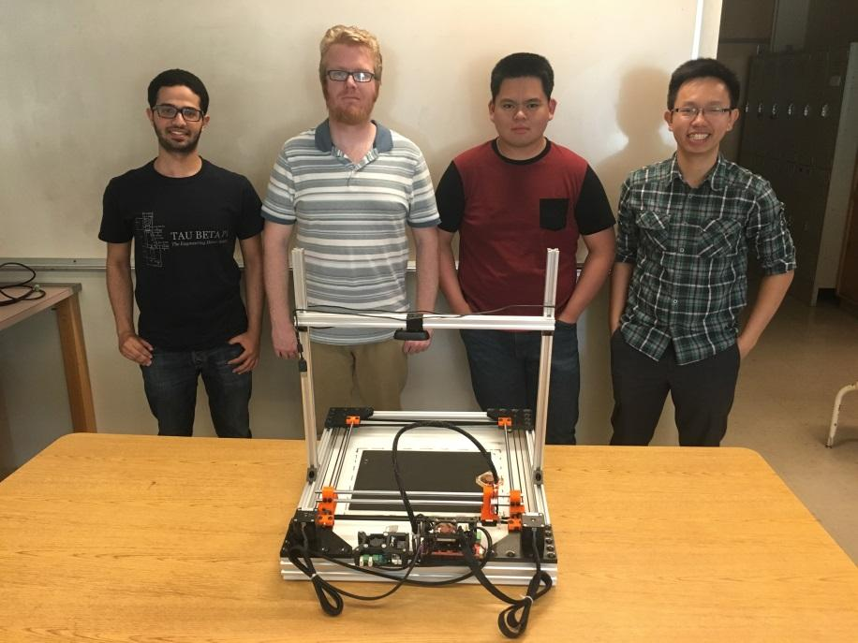

**Team Members**

From left to right: Ammar Ahmed, Thomas Bock, Michael Golez,

Tan Hua

**Ammar Ahmed -** Ammar is a senior, majoring in Electrical Engineering at Sacramento State University. His focus is in control systems with a small emphasis in Analog Design. His contribution towards the project was the development of the computer vision system. This system was implemented to get the dimension and location of the object in the working space. Currently, he is the controls team lead of the Hornet Hyperloop club. Also, he is a tutor at the Math department at CSUS.

**Thomas Bock -** Thomas is a first semester senior majoring in Electrical Engineering at Sacramento State, with a focus on control systems. His contribution to the project was the design and construction of the frame and linear motion system of the laser cutter. This system allows for accurate and reliable motion of the laser. He is currently the President of the 3D Printing Club at CSUS

**Michael Golez -** Michael is a senior engineer at California State University, Sacramento, majoring in Electrical Engineering. His primary focus is Digital/Analog Systems with a small emphasis in Control Theory. In the design of the CNC laser system, his contributions include the powering and operation of the laser diode and laser control circuitry. This involved designing and implementing a constant current source that can operate the laser safely.

**Tan Hua -** Tan is a Communication System Engineer with a minor focus on Digital Signal Processing. Over the years at Sacramento State, he spent time practicing software development. Currently he is working as an I.T. support for the state. As a result, his main focus towards the project would be the software implementation towards controlling the CNC laser system.

## Detailed Description

In order to design the CNC laser cutter and engraver, research was made on the components needed to build the system. After spending a good amount of time researching and reading about specifications and features included in other CNC laser cutter machines, the team had a brainstorming meetings to come up with new features to make a better product. Our approach was to add more features to make the design simpler and enhance the interface and operation of the device. The following section discuss the four main parts that the team focused in order to design the product:

### Mechanics

The mechanics of the laser system are based on a Core-XY or H-bot motion theory. This theory, popularized by Ilan Moyer, a graduate of MIT, is a cartesian based motion system that relies on two motors with opposing belt paths and mounts to create a simple, fast, and light motion platform. A design illustration of the motion system is shown below.

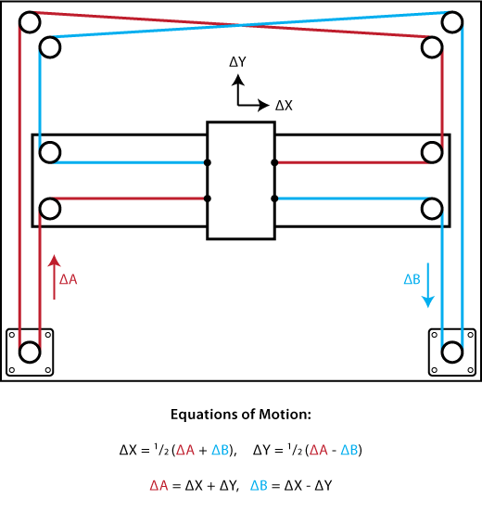

From the top-down illustration we can see the stationary motors and the belt paths and mounting. Motor A’s belt path is in red while motor B’s belt path is in blue. The red belt path is attached at the lower left of the center tool head, wraps around the motor pulley, up around two other pulleys, then is attached at the top right of the tool head. The blue belt path is a mirror to the red path, mounting at the lower right and top left of the center tool head. Note that the belts cross at the upper middle of the illustration. To allow this crossing, one of the belt paths must be offset in the z axis from the other, which was accounted for in our design. Now some of the key benefits of this design are simplicity, lightweight toolhead, and accuracy. The simplicity is achieved through the use of stationary motors and clever belt routing, which keeps the linear motion parts at the same amount or less, as other cartesian designs. The benefit of a lightweight toolhead is also due to the stationary motors. Mant cartesian style motion platforms mount at least one of the motors on either the x or y axis carriage. The motors are heavy, and can cause issues with binding or backlash due to the excess weight of the toolhead. The accuracy is improved based on the lightness of the toolhead and the minimal backlash in the system. Now after talking about why we chose this design, I can talk about how the mechanics were designed and built.

For the design I used Autodesk Fusion 360. This software is free to use if you sign up with a student account, which is what I did. I had only used CAD software before very briefly to design small parts for 3d printing, and had never used the software to build an assembly of parts. The software took a couple weeks to get familiar with to be able to design parts that would work for the machine. I modeled the linear rails, bearings, motors, and frame pieces first, then designed the other parts to fit the bought parts that would not be modified. The parts that were designed ( and their colors in the model) include:

* Four corner frame pieces (black)
* Four mounting brackets for the linear rods (red)
* Two carriage pieces (red)
* One toolhead(Silver

The final design of the laser cutter assembly can be seen below. This took into account the belt routing and the size of the nuts and bolts that were going to be used, even though they are not shown.

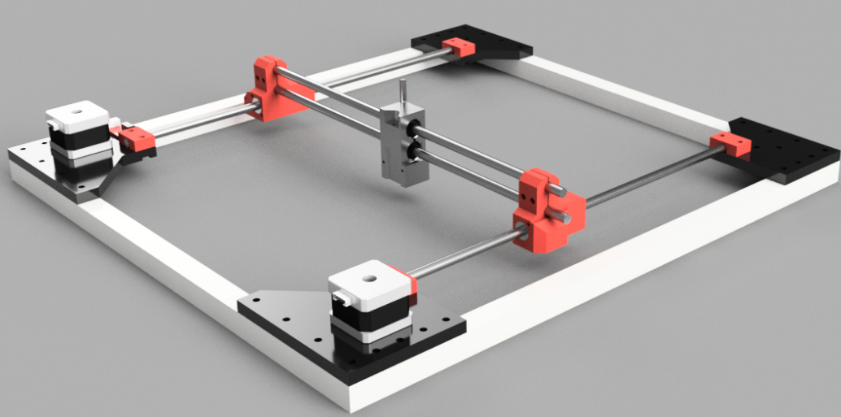

After the design was finished on the computer, the pieces created in the design had to be 3d printed. I have a 3d printer at home so I printed out the parts and assembled the frame. A couple of the pieces had to be slightly modified to fit which was updated in the design and the parts were reprinted.

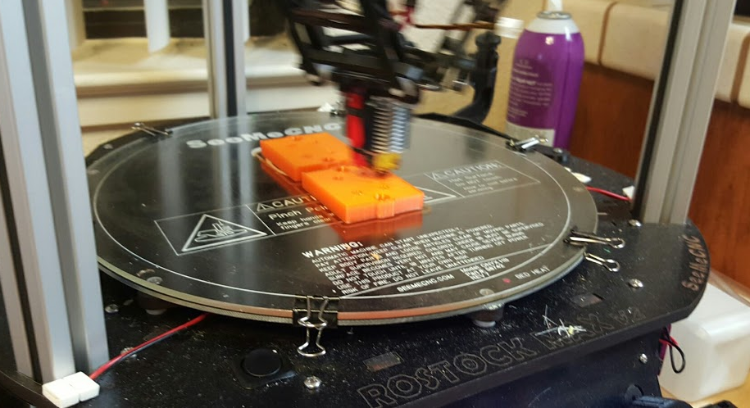

The final design of the assembled mechanics are seen below in the following image. After this design was completed, I had to design a camera mount for the webcam and that is seen in the finished laser cutter.

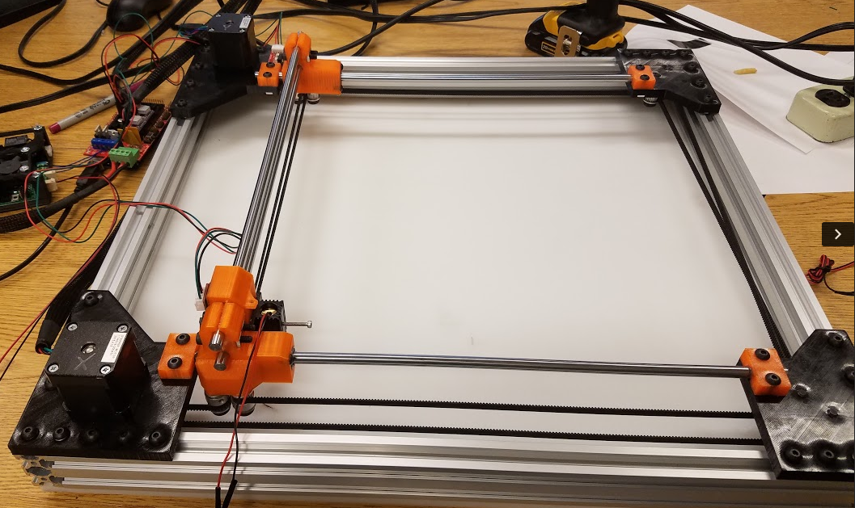

### Laser System

The operational function of the laser system will be solely dependent upon the microcontroller and laser driver attached towards the laser diode. A simple laser diode will conduct a high-energy beam that can cut or engrave a material prior to user command. However, both the microcontroller and laser driver will work on conjunction with each other. The overall purpose of the laser driver is to deliver a constant current source towards the laser diode in order for the system to operate at a particular application. However, regulating the intensity and precision of the engraving/cutting required the alteration of PWM. A controller is needed to vary the output of the laser so that upon engraving/cutting a material of interest it becomes precise and accurate to the desired requirement.

In order for the laser diode to function operationally, different types of drivers were tested and applied towards the laser diode:

1. 1.8 X-Drive V6 Laser Driver:

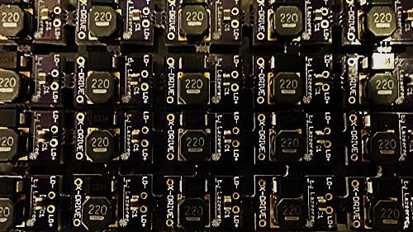

**Figure 1**

The 1.8X-Drive V6 Laser Driver was the first chosen laser driver to operate the laser diode. The reasoning for combining both the laser diode and X-Drive was the compatibility factor of the circuit with the 2W 445nm M140 Blue Diode. Further review listed from the vendor guaranteed that the driver has low noise capabilities along with self-bleeding caps to prevent spikes created by charged output caps. The circuit component became unnecessary because upon further inspection TTL was not compatible with the device. Another version known as the 4A Super X-Drive Laser Driver was considered, but upon inspection compatibility was not successful with the laser diode.

1. 12V TTL 200mW to 3W 445nm 450nm Laser Diode LD Power Supply Driver :

|  |  |
| --- | --- |
|  |  |

**Figure 2**

The 12V TTL 200mW to 3W 445nm 450nm Laser Diode (LD) Power Supply Driver replaced the X-drive because of its TTL capabilities. This circuit module provides both a current and voltage regulation towards the load, thus setting a constant source towards the laser diode. By having the user alter the output voltage and limit the current, the laser diode can operate within the region of operation. After setting the limit source, the TTL modulation can then vary the power of the laser by altering the PWM. The 12V TTL 200mW-3W Laser Diode Power Supply Driver was the main current driver used to power the laser until Compliant Laser Driver was purchased

1. 2.5 Amp Adjustable Safety Compliant Laser Diode Driver Kit, for UV-Blue diodes, with International Power Adapter:

|  |  |
| --- | --- |
|  |  |
|  |  |

**Figure 3**

The Compliant Laser Diode Driver replaced the previous drivers because of software compatibility and hardware features. Although the Compliant Laser Driver provides the same the capabilities as the 12V TTL Power Supply Driver, it also differed in many ways. One advantage the compliant laser driver provided was software compatibility with the Software programs such as: Matlab, InkScape, and Rasterization.

### Software

* + 1. Objective
       1. The purpose of software in this project is to control the process of the machine including cutting and engraving.
    2. Detailed Process
       1. Computer Aided Design (CAD)

In this step, we can place our desired design such as an image, a drawing, etc. into Inkscape, a computer aided design tool is commonly used for CNC machine. This step helps the user determine how the physical object will look like after cutting or engraving

* + - 1. Computer Aided Manufacturing (CAM)

The purpose of this step is to generate G-code instruction from the design we have from step 1. G-code is a commonly used industrial standard language to control automated machine tool. By using our written plugin called Q-Laser Plugin along with Inkscape, G-code instruction will be generated with stepper motors movement along with laser intensity.

* + - 1. Execution

In this step, G-code instruction that is generated in step 2, now in text file type, will be placed in Repetier Host, a software used to perform G-code instruction along with providing preview and estimated time of executing time. After hitting print, the machine will start running and executing on the physical object until it completes.

### Computer Vision

1. **Objective:** 
   1. To determine the location of the object in the working space with reference to the laser starting point.
   2. To get the dimension of the object to ensure that the cutting/engraving process stays within the boundaries of the object.
2. **Detailed process**

A webcam (LogiTech) was used as a sensor to accomplish our goal. The camera was mounted on top and parallel to the working space to ensure correct readings and for calibration purpose. The following are the detailed steps for the running the computer vision and the details for the image processing.

* 1. Computer

The process starts with connecting the camera to the computer through the USB connection and then open MATLAB to run the code. An extension for MATLAB has to be downloaded first in order to execute the code, otherwise it would show errors.

* 1. MATLAB

In this step, the algorithm for the object detection will be executed on MATLAB and the following are the steps needed for image processing in order to get the location and dimension of the object in the working space.

* + 1. First step in the code, image is captured that shows the actual object in the working space as shown in the figure below.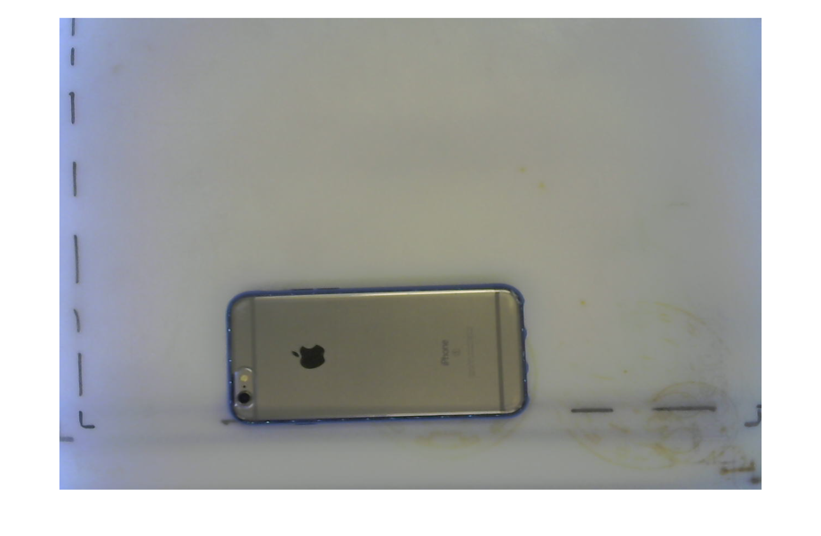

**Figure 3: Actual image captured through the camera of the object in the workingspace**

* + 1. The second step is converting this image into a binary image (black and white). This is done by setting a threshold value to the image conversion. Threshold value is used to set pixels on the image to black if the image intensity is less than the specified value and sets other pixels to white. The result is shown in the figure below.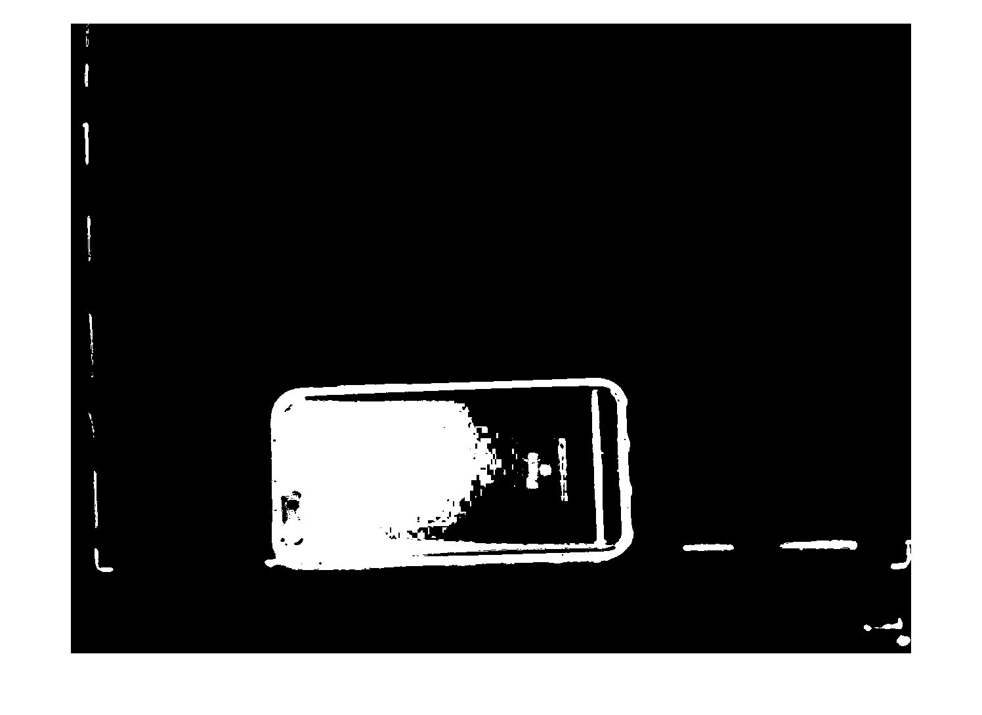

**Figure 4: Result of converting previous image to binary image**

* + 1. However, the picture has noise in the background which cause an error when running the code. Therefore, filter is applied to remove noise from the background to solve this issue. Another issue in the figure above is that the picture is not filled i.e the rectangular box (which represent the phone) is half black and half white. For this reason, Morphological operation (dilate) is applied to the image to fill out the gaps which enhance the quality of the binary image as shown in the figure below. 

**Figure 5 Image after filtering noise and applying Morphological transform**

* + 1. Lastly, it is easier now to detect the object and bounding box is applied to the image. Bounding box is an algorithm that detects white pixels in an image and draws a box around it. This helps in getting the size of the box and the location in pixel. These numbers will then be multiplied by a calibration factor to convert the pixel to real world unit “cm”. The figure below shows the final results for the image processing. At the bottom on the left half side of the figure below is the actual dimension in cm. The right side shows the object been detected and a red box (Bounding Box) is drawn around the object.

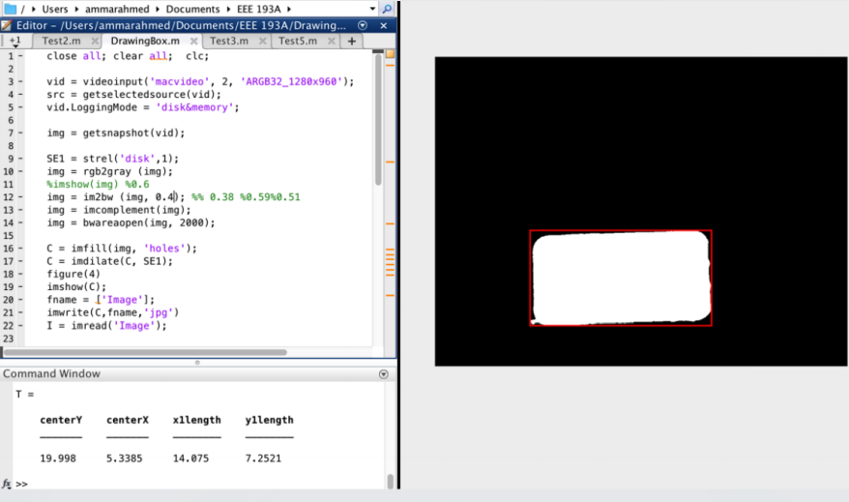

# **Proposals**

## Funding and Cost

In reference to finding allocated funds for the production of the Laser Cutter/Engraver, each individual member proposed a draft meeting to discuss the funds needed for the production of the CNC laser system. The desired funds for the 1st semester prototype were expected to be about $1000. Because the mechanical and hardware aspect of the project covered a majority of the project the expenses was divided between both parts. Below will be a summary of the expenses purchased by each individual member in reference towards the laser cutter.

1. Mechanics

|  |  |
| --- | --- |
| Components | Cost |
| 2.5 Amp Adjustable Safety Compliant Laser Diode Driver, for UV – Blue Diodes, US Style Plug | $114.99 |
| Low Profile M5 Screws 25pk | 3.15 |
| 6 x Black Angle Corner Connector | $16.50 |
| Tee Nuts 25 Pack | $4.95 |
| 3 x V-Slot Linear Rails 20x20 | $15.00 |
| 4 x V-Slot Linear Rails 20x40 | $22.00 |
| CycleMore 10M GT2-6mm Rubber Belt + 2PCS 5mm GT2-20 Teeth Timing Pulley | $23.99 |
| 2 of Cyclemore 5PCS Aluminum GT2 Pulleys 20 teeth | $27.18 |
| 5PCS DRV8825 Stepper Motor Driver | $17.99 |
| 4 of Linear Motion 8mm shaft, 406mm length | $51.16 |
| Signwise 3 pack Mechanical Endstop | $9.55 |
| 12 of LM8UU Linear Bearings | $12.99 |
| 2 of Noctua NF-A4X10-FLX 5V Fan | $27.40 |
| Hatchbox PETG 3D Printer Filament Black 1KG roll | $24.96 |
| eSun PETG 3D Printer Filament Orange 1KG Roll | $25.95 |
| Arduino Mega 2560 | $14.19 |
| RAMPS 1.4 board | $13.97 |
| 2 x NEMA 17 Stepper Motors | $34.00 |
| 12c 30a DC Power Supply | $23.97 |
| Various Nuts, Bolts, Washers | $60.00 |
| Plastic waste board | $30.00 |
| Sum | $573.89 |

1. Laser System

|  |  |
| --- | --- |
| Components | Cost |
| 1.8A X-Drive V6 Laser Driver | $26.00 |
| 12V Circuit Power Supply Driver Board | $13.15 |
| 12V Industrial Focusable Blue Diode Lasers | $104.50 |
| Addicore LM317T | $5.95 |
| 2 of QQ-Tech Goggles Laser Eye Protection Safety Glasses | $8.99 |
| 2W 445nm M140 Blue Diode in Copper Module W/Leads | $54.00 |
| AixiZ aluminum mount and heat sink for 12nm modules | $3.50 |
| 405-G-2 Glass Lens Aixiz Laser Module 405nm-445nm | $12.00 |
| uxcell SSR-25 DA 3-32V DC/24-380V AC Solid State Relay+heat Sink | $7.99 |
| uxcell Solid State Relay SSR-25 DD DC-DC 25A 3-32VDC/5-200VDC | $8.44 |
| Uxcell Aluminum Heat Sink for Solid State Relay SSR Heat Dissipation 10A-40A | $5.55 |
| Sum | $250.07 |

**Table 1**

1. Software

All components of software process are free open-sourced software including Inkscape, Repetier Firmware and Repetier Host. Therefore, it has zero cost.

1. Computer Vision

|  |  |
| --- | --- |
| Components | Cost |
| Logitech C270 720p 3-MP | $23.00 |

## Product Proposal

In reference to finding allocated funds for the production of the Laser Cutter/Engraver, each individual member proposed a draft meeting to discuss the funds needed for the production of the CNC laser system. The desired funds for the 1st semester prototype were expected to be about $1000. Because the mechanical and hardware aspect of the project covered a majority of the project the expenses was divided between both parts. Below will be a summary of the expenses purchased by each individual member in reference towards the laser cutter.

# Work Breakdown Structure (WBS)

## Outline of WBS

TODO(Mike) – Brief intro about WBS and a screen shot – rest can be put in appendix

### Mechanics

### Laser System

### Software

### Computer Vision

## Project Timeline

### Milestone I

Individual research and work for each main portion of the project including mechanics, laser system, software, and computer vision need to be accomplished in the first month of the project timeline.

### Milestone II

Integration of hardware including mechanics and laser system and integration of software including software and computer vision need to be started and done in the next two months of the project timeline.

### Milestone III

Full integration of hardware and software need to be started and done in the remaining time of the project timeline before final presentation and demonstration

**Gant Chart**

TODO(Mike) – Brief intro and screen shot – rest can be put in appendix

# Risk Assessment (Safety)

### Todo (Tom, Mike, Tan) – Safety from presentation

1. **Laser Emission Hazard**

Safety goggles are used at all time and operated in a secure area.

1. **Smoke Hazard**

External fan is used in a ventilated area

1. **Fire Hazard**

Temperature control is built into laser driver and machine is never left alone.

# User Manual

### Operation

* Safety considerations: Room Requirement, Objects to be cut/Engrave, Goggles

### Hardware Requirements

* Computer
* Power Supply
* On/Off switch

### Software Requirements

* MATLAB, Inkscape with Q-Laser Plugin, Repetier Host

### Execution

Step 1. Place the object on workspace

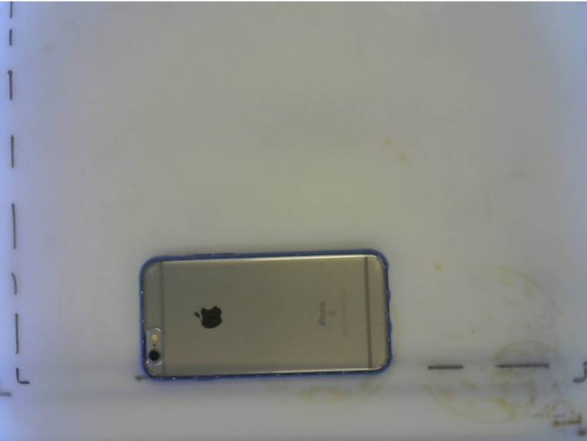

Step 2. Run MATLAB to obtain location and dimensions of the object



Step 3. Place the design on Inkscape accordingly

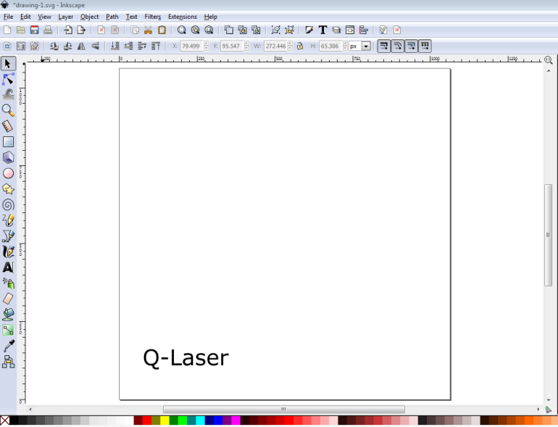

Step 4. Using Q-Laser plugin to generate G-code instruction

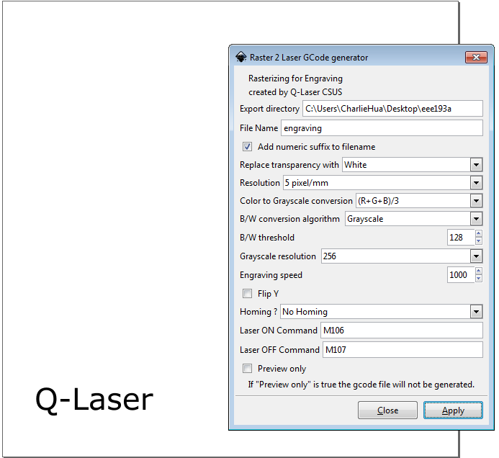

Step 5. Using Repetier Host to preview and click print to start the process

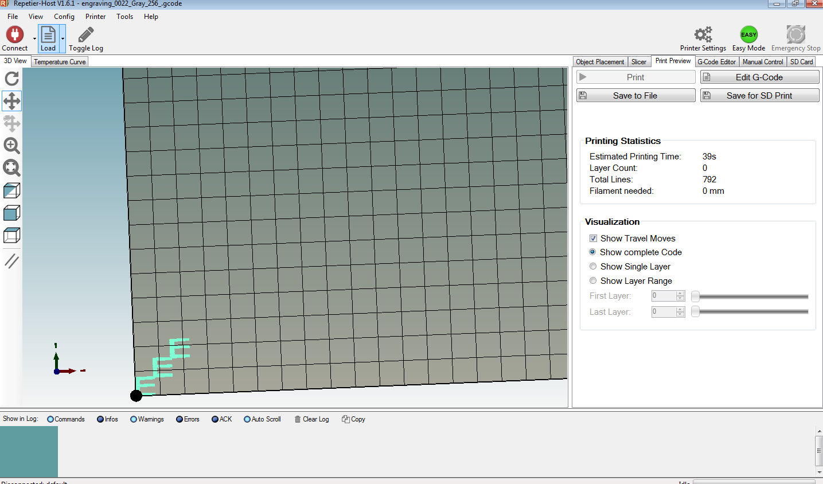

# Design Documentation

# Breakdown of Hardware Subsystems

### Camera

First hardware component that begins the process is the camera. In our project, we use computer webcam because of its great compatibility with the computer. It is used to capture the object that is placed on the workspace and obtain the object dimensions.

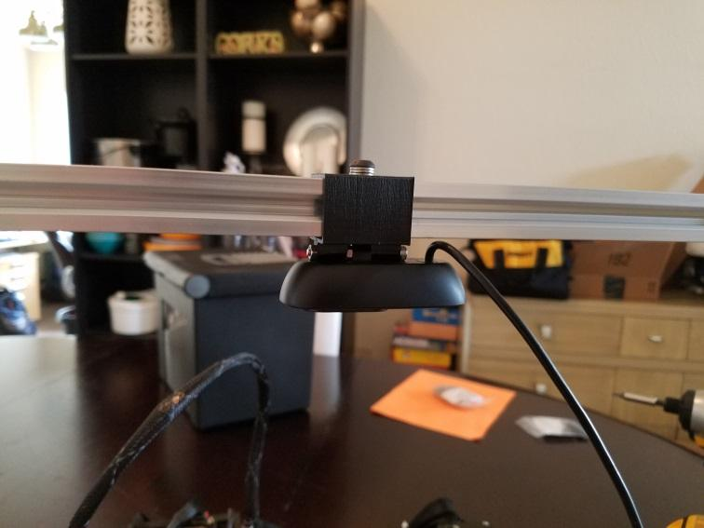

### Laser Diode

Laser Diode is the core of laser system used for this project. The laser diode along with laser driver will drive the laser out with particular intensity level depending on the design.

### Microcontroller – Stepper Motor Driver Shield

Microcontroller is the core of the hardware system. In this project, we use Arduino MEGA 2560 to control the stepper motors for core x-y movement, laser driver for laser intensity and so on. Moreover, in order to maximize the efficiency, we use stepper motor driver shield RAMPS 1.4 on top of the Arduino MEGA 2560, which is commonly used for 3-D printing applications.

### Block diagram

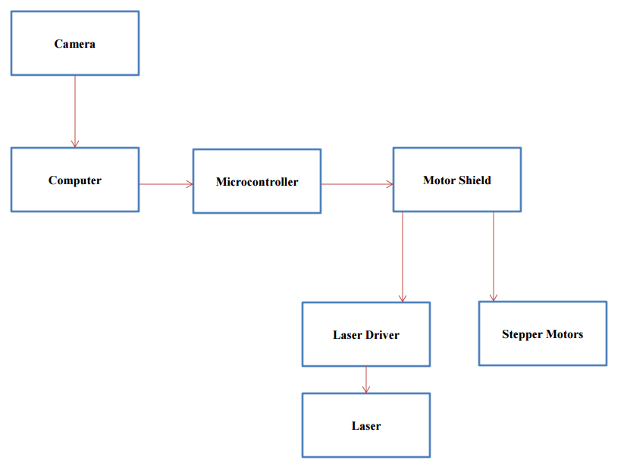

# Breakdown of Software Subsystems

TODO (TAN)

### Object Detection Algorithm

Using MATLAB with a lot of useful built-in functions and toolbox, the location and dimensions of any object can be measured and sent to Inkscape, CAD tool used for this project.

### Design and Generate G-Code instruction

After obtaining the location and dimensions of the object from MATLAB algorithm, location coordinates along with width and height of the object will be input in Inkscape. Then, the desired design will be placed accordingly on the object location we determine before. Then G-code instruction will be generated through Q-Laser plugin.

### Stepper Motor and Laser control

G-code instruction will be placed in Repetier Host software, and it will execute these instructions as it describes to obtain the physical product.

### Flow Chart

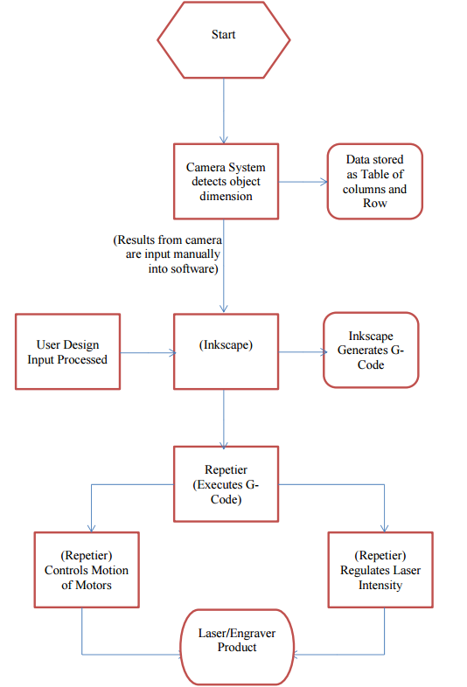

# Mechanical Drawings and Documentation

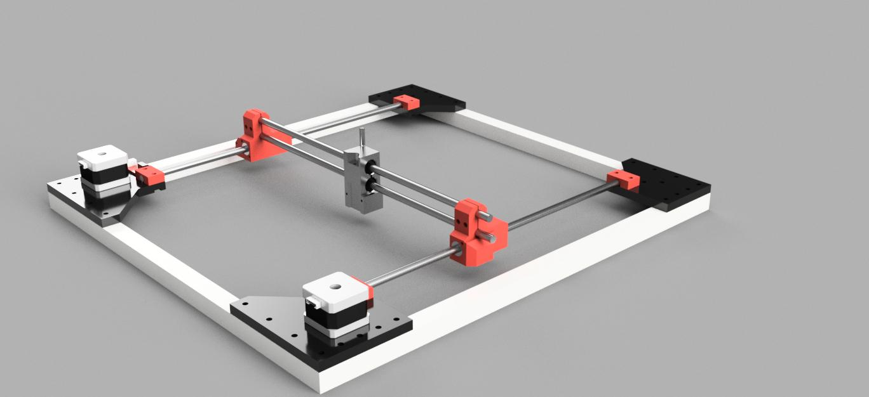

# Test Plan for Hardware

1. 3D Printed Parts
   1. Check dimensions
   2. Check rigidity
   3. Add mounting hardware
   4. Test for looseness
2. Linear Motion Parts
   1. Check Rods for straightness
   2. Grease Bearings
   3. Test Bearings for smoothness
3. Frame
   1. Assemble Frame
   2. Check squareness
   3. Check rigidity
4. Assembly
   1. Assemble Frame
   2. Add 3d printed parts
   3. Add linear motion parts
   4. Add nuts and bolts
   5. Check dimensions
   6. Check for cracks
   7. Add and tighten belts
   8. Check for binding

# Test Plan for Software

1. Microcontroller Test
   1. ZeroPi
   2. Arduino Uno 3
   3. Arduino Mega 2560 + RAMPS 1.4
2. Software Test
   1. Operating System
   2. Inkscape
   3. Plugin
   4. Repetier Host

# Integration Plans

#### Mechanics-

The majority of the project was integrated over the spring break. This is when the final assembly of the mechanical parts occurred and the laser parts were mounted to the mechanics. The firmware for the microcontrollers was installed at this point and several hours worth of work went into modifying the firmware to run the movement of the laser cutter. At this point we were able to finally test out the mechanics and see the toolhead move.

# Accomplishment

1. Accomplishments
   1. Machine is fully operational
   2. Cost is under budget
   3. Minimum size requirements are met
2. Design Improvement Ideas
   1. Filtration System
   2. Machine Enclosure
   3. Improve Engraving Algorithm
   4. Improve camera accuracy in measurements
   5. Automatic communication between camera system and software.

# Conclusion

Todo(Tom) – From presentation

# Appendix A: References

* <http://corexy.com/>
* <http://jtechphotonics.com/>
* <http://reprap.org/wiki/RAMPS_1.4>
* <https://www.repetier.com/>
* <http://openbuilds.com/>

# Appendix B: Code

TODO(Tan)